Michelle Leonforte
3210
Civic@broxtowe.gov.uk

7th October 2020

To all local organisations,

Dear all,

Remembrance Sunday – 8th November 2020

As you will be aware, the pandemic has impacted on event programmes around the world and this year’s Remembrance Services are no exception.

The annual Remembrance Sunday commemorations are a significant event in the Borough’s calendar, which allows us all the opportunity to pay tribute to those who have made the ultimate sacrifice for our country.

It is important that we are still able to mark this important day. However, the Government has issued clear guidance about the numbers of people who are allowed to gather and we must follow this guidance when organising this year’s Remembrance events.

This means that we will be unable to permit parades to take place as part of Remembrance this year.

It also means that the number of people allowed to take part in the wreath laying ceremonies at our war memorials will be restricted to six people, as part of a private ceremony.

We will be asking residents not to gather at war memorials at 11:00am to ensure we can keep everyone safe and asking them to participate in the act of Remembrance from home. Marshals will be in place to advise residents who do turn up at the memorial at 11:00am how they can take part in the act of Remembrance at home.

Rest assured, we will be putting measures in place to enable this to take place including:
- Live streaming the event for residents to take part from home
- Those wishing to lay a wreath will be able to do so at different times throughout the weekend, provided that COVID-19 guidance is followed at all times.

I know this will be a great disappointment to you and it is with a heavy heart that we have had to make this decision. However, it is our duty to keep our community safe.

We will continue to review our plans as new Government guidance is issued.

Thank you for your ongoing support as we work to beat the virus together.

Yours sincerely,

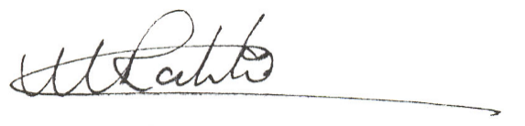

Councillor Milan Radulovic
Leader of Broxtowe Borough Council

